**Hospital Management System Feasibility Report**

Subject: Software Engineering Process Management

Shivam Tawari (A-49)

Hospitals are mind-boggling framework, from the enlisted patients, clinical administrations, assigned costs, requesting new medication before the stock runs out, watching out for terminated medications, inescapable line of patients and clinical hardware stock.

In the conventional administration framework, a patient needs to get in line before arriving at the specialist. While this can't be changed yet the holding up time can be diminished if another legitimate administration framework is proposed. Numerous multiple times expanding the workforce fulfills the need however aimlessly expanding the pointless inert gear and works is a misuse of assets and would build the administration cost and never adjusting the administration quality to cost proportion.

There are numerous issues in customary framework. So as to improve administration quality, decrease administration costs, present day medical clinic executives must face these issues. In this way, there is a need of new administration framework.

Hospital is a complex system, from the registered patients, medical services, designated prices, ordering new medicine before the stock runs out, keeping eye on expired drugs, inevitable queue of patients and medical equipment inventory.

In the traditional management system, a patient has to get in queue before reaching the doctor. While this can’t be changed but the waiting time can be reduced if a new proper management system is proposed. Many a times increasing the workforce satisfies the need but blindly increasing the unnecessary idle equipment and labors is a waste of resources and would increase the service cost and never balancing the service quality to cost ratio.

There are many problems in traditional system. In order to improve service quality, reduce service costs, modern hospital administrators must be facing these issues. Therefore, there is a need of new management system.

**Queuing Theory –**

Through arithmetic and quantitative techniques, the target of a complex arrangement of lining conduct of the structure and dynamic recreation studies, science, and precisely depicts the likelihood of the line, the line of activities research is a significant branch. In medical clinic the board, if the lining hypothesis based on the emergency clinic out-tolerant, the lining framework's office of the structure and conduct of the logical reproduction and frameworks. What's more, the specialist's office to mastermind ideal plan, to acquire basic qualities of their frameworks to mirror the quantity of pointers of results, gauge, investigation or assessment, the most extreme to address the issues of patients and their families, will adequately maintain a strategic distance from misuse of assets.

Through the lining hypothesis to the lack of medical clinic business examination, a PC the executives framework for emergency clinic utilize is inescapable, the report shows that usage of data the executives can upgrade the general picture of the clinic, the clinic individuals to successfully feel the normalization and modernization Management, upgrade the nearby clinic in the impact of seriousness, in order to upgrade the financial advantages of the emergency clinic; improve the data the board framework can assist medical clinics with accomplishing logical precision of interior administration.

The emergency clinic data framework work viably, could essentially improve the division's work effectiveness and quality, decreasing different administrations take a shot at the physical work power. Simultaneously improve the exactness of data to guarantee that the Hospital Finance, is zoned cost, compelled, and different parts of the human mistake rate hits zero, with the goal that the clinical staff to discharge more vitality and time to serve the patients and guarantee monetary interests of the patients simultaneously make financial advantages for the Hospital.

Through mathematics and quantitative methods, the objective of a complex system of queuing behavior of the structure and dynamic simulation studies, science, and accurately describes the probability of the queue, the queue of operations research is an important branch. In hospital management, if the queuing theory on the basis of the hospital out-patient, the queuing system's office of the structure and behavior of the scientific simulation and systems. And the doctor's office to arrange for optimal design, to obtain essential characteristics of their systems to reflect the number of indicators of results, forecast, analysis or evaluation, the maximum to meet the needs of patients and their families, will effectively avoid waste of resources.

Through the queuing theory to the shortage of hospital business analysis, a computer management system for hospital use is inevitable, the report shows that implementation of information management can enhance the overall image of the hospital, the hospital people to effectively feel the standardization and modernization Management, enhance the local hospital in the influence of competitiveness, so as to enhance the economic benefits of the hospital; improve the information management system can help hospitals achieve scientific accuracy of internal management. Hospital management in the past because all information is imperfect, is not accurate, timely information often do not have a patient cost leakage, run, the wrong fees; materials management of information is not accurate, the resources of its own hospitals unknown, the backlog caused by waste, and were not the best use. Drugs such as the management, use of the country under the GSP management standards, making local hospitals in the drug supply management and the validity of drug management, and other areas more convenient norms, greatly enhance the safety of hospital treatment.

The hospital information system operate effectively, could significantly enhance the department's work efficiency and quality, reducing various services work on the manual labor intensity. At the same time improve the accuracy of information to ensure that the Hospital Finance, is zoned price, under doctor's orders, and other aspects of the human error rate hits zero, so that the medical staff to release more energy and time to serve the patients and ensure economic interests of the patients at the same time create economic benefits for the Hospital.

**AI Model –**

AI algorithms can be applied to x-rays and scans to correctly classify whether a person has a disease or not.

This can drastically decrease the work load on Doctors. To be precise, Deep Learning methods have to be applied in the scans. Convolutional Neural Networks has proved to be the one true state of the art.

Introducing this approach can not only reduce workload but also reduce waiting times of scan results and increase in overall satisfaction of the patient. This also reduces queue waiting time as now the doctor is more concentrated on analyzing patients rather than reading reports.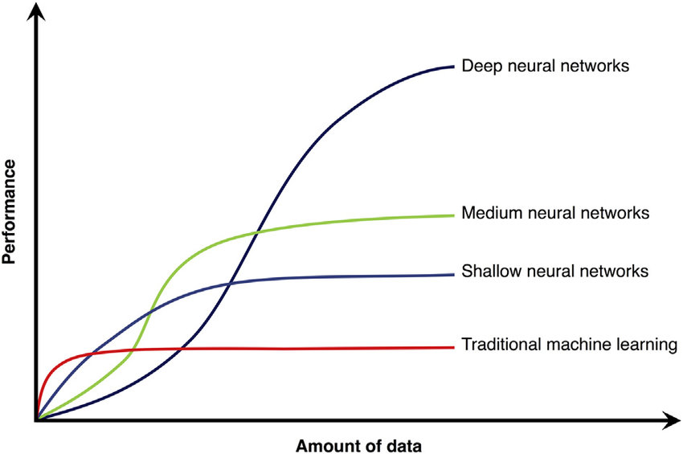

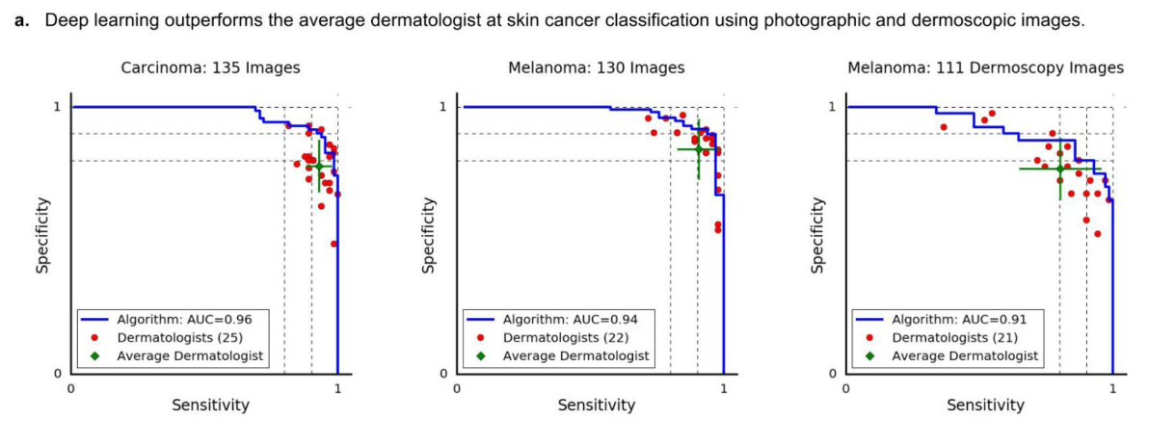

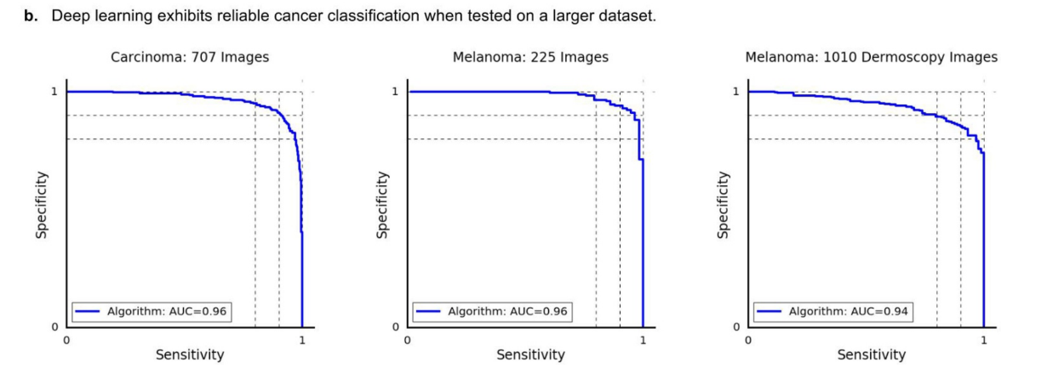

Recent studies on Skin Cancer Detection have found that Deep Neural Networks can classify Skin Diseases better than professional doctors.

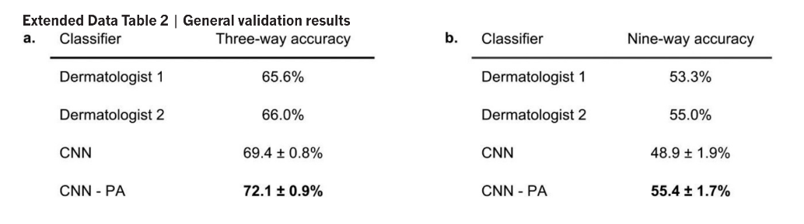

Conclusions:

In the hospital line it is normal, as patients and medical services are at random, with the amount of theoretical resources unlimited, and the medical resources limited. Limited resource allocation, use of line estimation and computer simulation, combined with an appropriate data service record, performing benchmarks and quantitative data, then forecasting, analyzing and evaluating, optimizing construction, implementing robust management, hospital capacity, institutional and equipment improvements, statistical increase of medical staff, medical clinics improve technology, and reduce the average clinical time and their level of fitness, increase efficacy, reduce waiting time, integrated treatment protocols for patients. Apparently, the use of an on-line concept, on the other hand can effectively solve the hospital services system in the allocation of personnel and equipment problems, with hospital managers providing a reliable basis for decision making. On the other hand, with an AI program that identifies patients with the disease. Both reduce the time that patients wait, not the waste of hospital resources, thus achieving the greatest social and economic benefits.

References:

1. <https://stelizabethseast.com/wp-content/uploads/2015/06/FINAL-Hospital-Feasibility-Study-Print-Lo-Res-Final.pdf>
2. <https://www.ncbi.nlm.nih.gov/pmc/articles/PMC3644748/>
3. Dermatologist-level classification of skin cancer with deep neural networks by Andre Esteva, Brett Kuprel, Roberto A. Novoa, Justin Ko, Susan M. Swetter, Helen M. Blau & Sebastian Thrun